**Calculator Assumed**

**Topic: Trigonometry and Applications**

Time: 45 minutes

Total Marks: 45

Your Score: / 45



**Question One: [2, 2, 3 = 7 marks]**

Calculate the value of the unknown in each of the following triangles.

1. 
2. 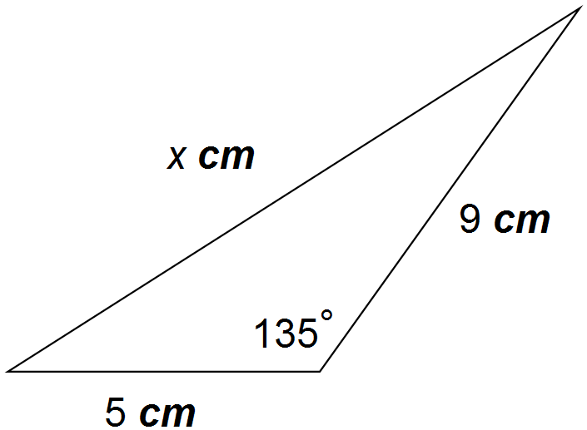

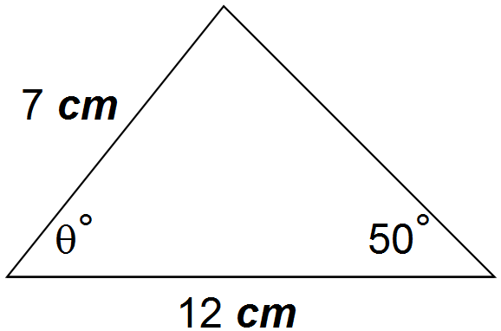**Question Two: [2, 2 = 4 marks]**

1. Calculate the value of the unknown acute angle in this triangle.



1. Hence, or otherwise, determine whether the known dimensions of the triangle, that is those given in the diagram, could produce an obtuse angle triangle. Explain your reasoning.

**Question Three: [5 marks]**

The area of an acute isosceles triangle is .

If the angle between the two equal sides is , calculate the perimeter of the triangle.

**Question Four: [2, 2, 2, 2, 1 = 9 marks]**

Paul is planning his cycling route and intends to cycle up a few hills.

His first steep climb has an average gradient of 9% . This means that for every 10 km of horizontal distance travelled, Paul has climbed 900 m.

1. Determine the angle of elevation of his first climb.
2. This first climb has an actual horizontal distance of 4 km. How far vertically has Paul cycled?

On a second steep climb the average angle of elevation is 9.09˚. Paul climbs this hill for a horizontal distance of 2 km.

1. How far vertically has Paul cycled?
2. What is Paul’s approximate travel distance on this second climb?
3. What is the gradient of this climb, as a percentage?

**Question Five: [3, 2, 3 = 8 marks]**

Robin is going for surfing. The shoreline runs perfectly north/south and she paddles out from the shore on a bearing of 290˚ for 150 m. She then paddles a further 80m on a bearing of 278˚ and waits for the perfect wave to come in.

1. Draw a diagram of this situation.
2. Calculate the direct distance from the shore to where Robin waits for a wave.
3. On what bearing could she have paddled to end up at this final position?

**Question Six: [3, 5, 4 = 12 marks]**

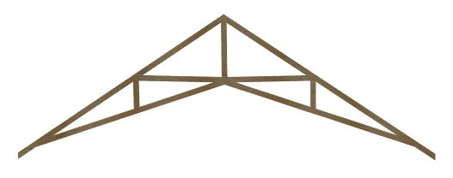To create a vaulted ceiling, a series of roof trusses, like the one pictured, must be built from wood.

The vertical piece of wood in the centre is 1.8m long.

This vertical piece of wood sits in the centre of an

acute isosceles triangle, with equal angles of 42˚.





1. Label this information on the diagram and hence find the base length of the isosceles triangle.
2. Supporting the base of the isosceles triangle are two vertical struts, each of length 0.6m. Use this information to help calculate the length of wood from A to B.
3. The truss has small pieces of overhang that will hang over the external walls and outside the room of the building. Use the information above to determine the width of the room, that is, the distance from B to D.

**SOLUTIONS**

**Calculator Assumed**

**Topic: Trigonometry and Applications**

Time: 45 minutes

Total Marks: 45

Your Score: / 45



**Question One: [2, 2, 3 = 7 marks]**

Calculate the value of the unknown in each of the following triangles.

1. 

 

1. 



 

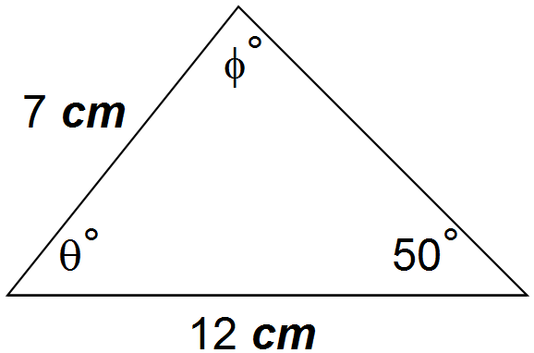

**Question Two: [2, 2 = 4 marks]**

1. Calculate the value of the unknown acute angle in this triangle.





1. Hence, or otherwise, determine whether the known dimensions of the triangle, that is those given in the diagram, could produce an obtuse angle triangle. Explain your reasoning.

148.37˚ is the obtuse angle, supplementary to 31.63˚, that gives the same ratio for sine from part (a). When added to 22 we obtain 170.37˚, leaving 9.63˚ left for the third angle.



**Question Three: [5 marks]**

The area of an acute isosceles triangle is .

If the angle between the two equal sides is , calculate the perimeter of the triangle.



**Question Four: [2, 2, 2, 2, 1 = 9 marks]**

Paul is planning his cycling route and intends to cycle up a few hills.

His first steep climb has an average gradient of 9% . This means that for every 10 km of horizontal distance travelled, Paul has climbed 900 m.

1. Determine the angle of elevation of his first climb.



1. This first climb has an actual horizontal distance of 4 km. How far vertically has Paul cycled?



On a second steep climb the average angle of elevation is 9.09˚. Paul climbs this hill for a horizontal distance of 2 km.

1. How far vertically has Paul cycled?



1. What is Paul’s approximate travel distance on this second climb?





1. What is the gradient of this climb, as a percentage?



**Question Five: [3, 2, 3 = 8 marks]**

Robin is going for surfing. The shoreline runs perfectly north/south and she paddles out from the shore on a bearing of 290˚ for 150 m. She then paddles a further 80m on a bearing of 278˚ and waits for the perfect wave to come in.

1. Draw a diagram of this situation.

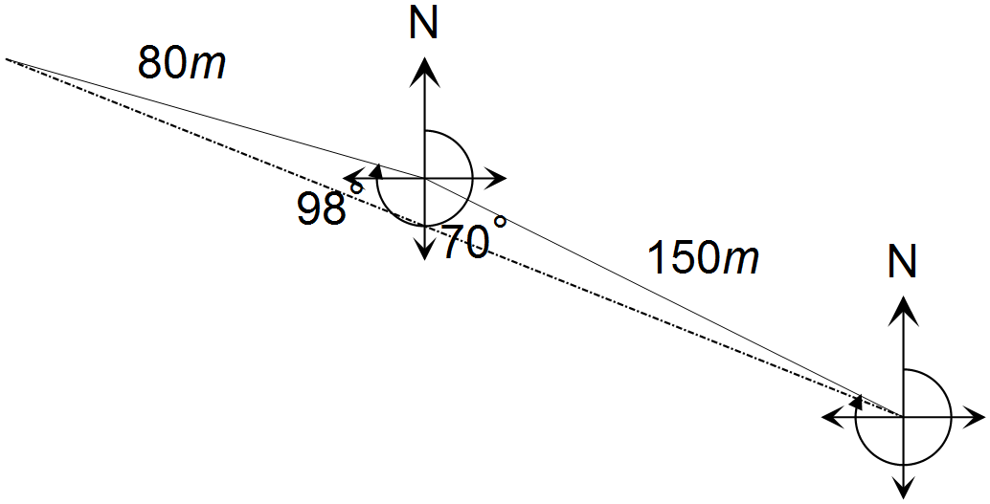







1. Calculate the direct distance from the shore to where Robin waits for a wave.





1. On what bearing could she have paddled to end up at this final position?



**Question Six: [3, 5, 4 = 12 marks]**

****To create a vaulted ceiling, a series of roof trusses, like the one pictured, must be built from wood.

The vertical piece of wood in the centre is 1.8m long.

This vertical piece of wood sits in the centre of an

acute isosceles triangle, with equal angles of 42˚.





1. Label this information on the diagram and hence find the base length of the isosceles triangle.



1. Supporting the base of the isosceles triangle are two vertical struts, each of length 0.6m. Use this information to help calculate the length of wood from A to B.



1. The truss has small pieces of overhang that will hang over the external walls and outside the room of the building. Use the information above to determine the width of the room, that is, the distance from B to D.



